8. ročník Okresní pohárové soutěže
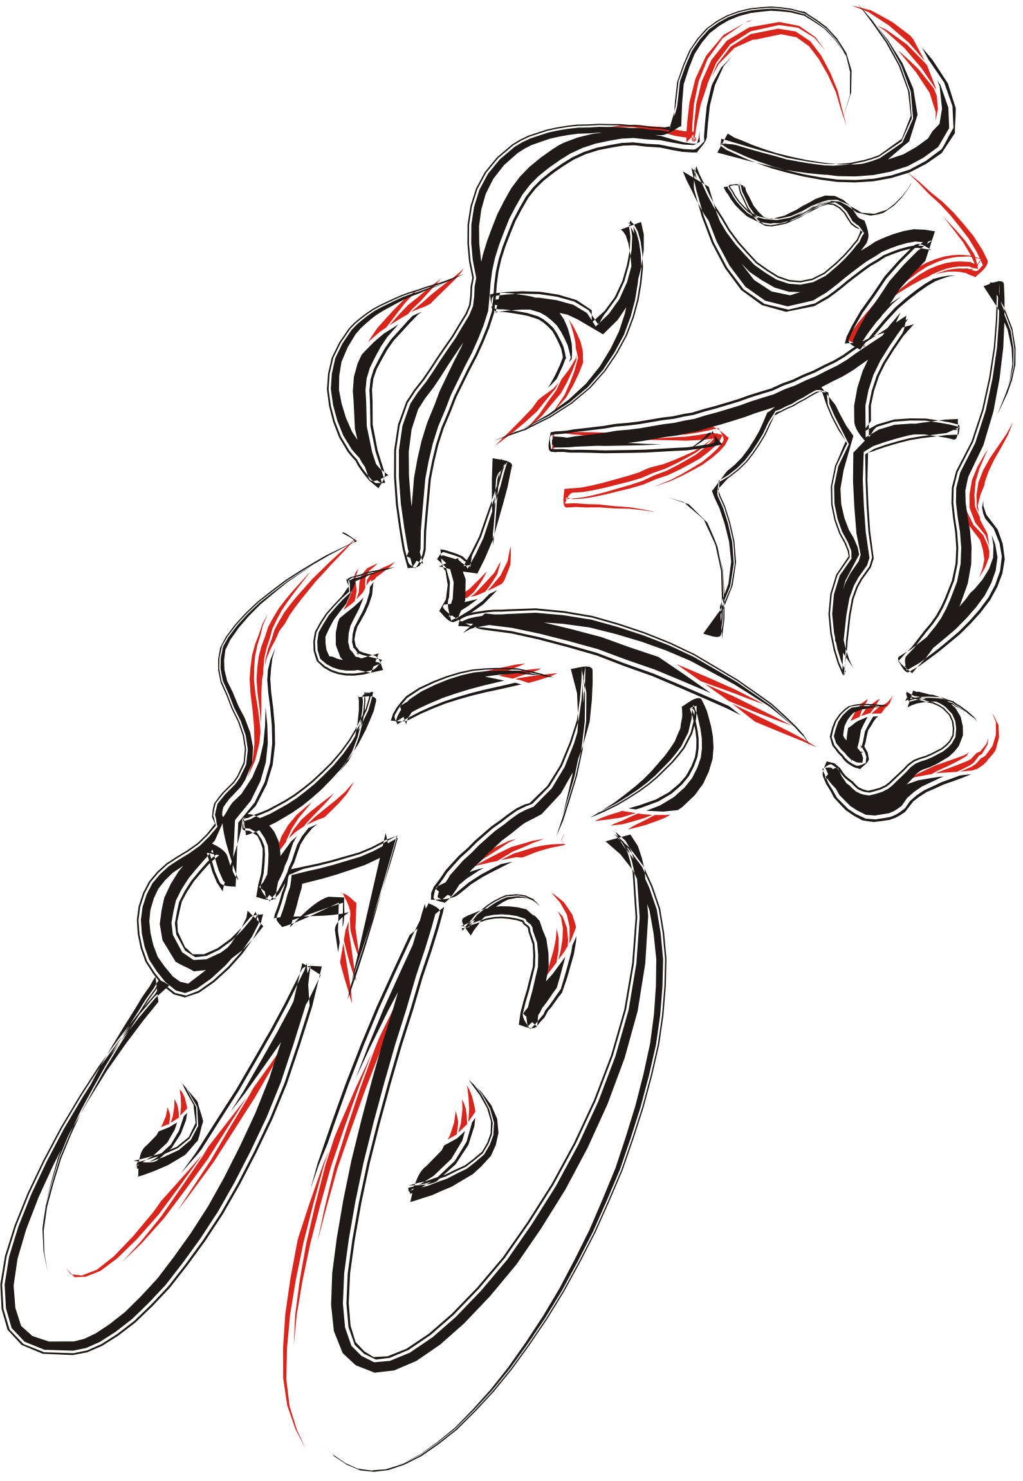
MTB – cross country pro rok 2009

Průběžné pořadí po 5. odjetých závodech :

Žákyně a mladší žáci :
1. |  | 1997 |  | Depta Martin |  | SK Maxbike Orlová A |  | 10 | 30 | 12 |  |  | 12 |  |  |  |  | 64
2. |  | 1997 |  | Glogovský Daniel |  | SK Maxbike Orlová A |  | 12 |  | 15 |  | 12 | 15 |  |  |  |  | 54
3. |  | 1998 |  | Pilchovská Aneta |  | SK Šafrata Bohumín A |  | 7 | 16 | 8 |  |  | 10 |  |  |  |  | 41
4. |  | 1996 |  | Mudříková Kateřina |  | TJ Bohumín - Kolík |  |  | 24 |  |  | 10 |  |  |  |  |  | 34
5. |  | 1997 |  | Lehocký David |  | SK Maxbike Orlová B |  |  | 20 |  |  | 8 |  |  |  |  |  | 28
6. |  | 1998 |  | Míček Matěj |  | SK Maxbike Orlová A |  | 8 |  | 10 |  |  |  |  |  |  |  | 18
7. |  | 1995 |  | Rezková Aneta |  | SK Maxbike Orlová A |  | 15 |  |  |  |  |  |  |  |  |  | 15
8. |  | 1999 |  | Ptáčník Matěj |  | SK Maxbike Orlová |  |  |  |  |  | 15 |  |  |  |  |  | 15
9. |  | 1999 |  | Wala Vojtěch |  | SK Maxbike Orlová |  |  |  |  |  |  | 8 |  |  |  |  | 8

Starší žáci a kadetky :
1. |  | 1996 |  | Wala Jan |  | SK Maxbike Orlová A |  | 15 | 30 | 15 |  | 15 | 15 |  |  |  |  | 90
2. |  | 1994 |  | Šafratová Nela |  | SK Šafrata Bohumín B |  | 12 | 24 |  |  |  |  |  |  |  |  | 36

Kadeti :
1. |  | 1994 |  | Polách Martin |  | SK Sport Klapka A |  | 10 | 24 |  |  | 15 |  |  |  |  |  | 49
2. |  | 1994 |  | Fierla Ondřej |  | CK Feso Petřvald |  | 12 | 30 |  |  |  |  |  |  |  |  | 41
3. |  | 1994 |  | Kožušník Adam |  | SK Maxbike Orlová A |  | 15 |  |  |  |  | 15 |  |  |  |  | 30
4. |  | 1994 |  | Sznapka Martin |  | SK Sport Klapka A |  | 8 | 20 |  |  |  |  |  |  |  |  | 28
5. |  | 1994 |  | Keisler Jiří |  | SK Šafrata Bohumín B |  | 7 | 16 |  |  |  |  |  |  |  |  | 23
6. |  | 1994 |  | Netri Filip |  | SK Maxbike Orlová |  |  |  | 15 |  |  |  |  |  |  |  | 15

Ženy a juniorky :
1. |  | 1992 |  | Bartošová Denisa |  | SK Maxbike Orlová B |  | 15 | 30 | 15 |  | 15 | 15 |  |  |  |  | 90
2. |  | 1988 |  | Lagová Alena |  | SK Šafrata Bohumín A |  | 12 | 24 |  |  |  | 10 |  |  |  |  | 46
3. |  | 1991 |  | Gnojková Katrin |  | SK Šafrata Bohumín B |  |  |  |  |  |  | 12 |  |  |  |  | 12
4. |  | 1986 |  | Pyszková Kristina |  | SK Šafrata Bohumín B |  |  |  |  |  |  | 8 |  |  |  |  | 8

Muži a junioři :
1. |  | 1990 |  | Rakušan Vojtěch |  | SK Maxbike Orlová B |  | 15 | 15 |  |  |  | 15 |  |  |  |  | 45
2. |  | 1989 |  | Grepl Radim |  | SK MADT Sport Klapka A |  | 7 | 24 | 12 |  |  |  |  |  |  |  | 43
3. |  | 1992 |  | Hanusek Tomáš |  | SK MADT Sport Klapka B |  |  | 30 |  |  |  |  |  |  |  |  | 30
4. |  | 1992 |  | Ryšavý Tomáš |  | SK Maxbike Orlová B |  | 6 | 20 |  |  |  |  |  |  |  |  | 26
5. |  | 1985 |  | Malošík Jan |  | CK Orlík Orlová |  | 10 |  |  |  | 15 |  |  |  |  |  | 25
6. |  | 1992 |  | Jurák Jakub |  | SK Maxbike Orlová B |  | 12 |  |  |  |  |  |  |  |  |  | 12
 |  | 1992 |  | Boršický Denis |  | CK Orlík Orlová |  |  |  |  |  |  | 12 |  |  |  |  | 12
8. |  | 1992 |  | Rezek Dominik |  | SK Maxbike Orlová B |  | 8 |  |  |  |  |  |  |  |  |  | 8

Masters mladší :
1. |  | 1970 |  | Galuška Tomáš |  | SK Šafrata Bohumín A |  | 12 | 30 | 12 |  | 15 | 10 |  |  |  |  | 79
2. |  | 1975 |  | Byrtus Ivo |  | SK MADT Sport Klapka A |  | 15 | 24 | 15 |  |  | 15 |  |  |  |  | 69
3. |  | 1970 |  | Sýkora Miroslav |  | SK Šafrata Bohumín A |  | 7 | 16 | 8 |  | 12 | 8 |  |  |  |  | 51
4. |  | 1973 |  | Hartig David |  | SK Šafrata Bohumín A |  | 8 | 14 | 10 |  | 10 | 7 |  |  |  |  | 49
5. |  | 1969 |  | Fierla Jan |  | CK Feso Petřvald |  |  | 20 |  |  |  |  |  |  |  |  | 20
6. |  | 1971 |  | Tureček Martin |  | SK MADT Sport Klapka B |  |  | 12 |  |  |  |  |  |  |  |  | 12
 |  |  |  | Kubala Janusz |  | SK MADT Sport Klapka |  |  |  |  |  |  | 12 |  |  |  |  | 12
8. |  |  |  | Klapka Vlastimil |  | SK MADT Sport Klapka A |  | 10 |  |  |  |  |  |  |  |  |  | 10
9. |  | 1966 |  | Lepšík Miroslav |  | SK MADT Sport Klapka B |  |  |  |  |  | 8 |  |  |  |  |  | 8
10. |  | 1973 |  | Mudřík Josef |  | TJ Bohumín - Kolík |  |  |  |  |  | 7 |  |  |  |  |  | 7
11. |  | 1973 |  | Wojaczek Martin |  | TJ Baník Karviná 1.máj |  |  |  |  |  | 6 |  |  |  |  |  | 6
 |  | 1968 |  | Fajkus Martin |  | SK Šafrata Bohumín B |  |  |  |  |  |  | 6 |  |  |  |  | 6

Masters starší :
1. |  | 1957 |  | Baier Jan |  | TJ Bohumín - Kolík |  | 15 | 30 | 15 |  | 15 |  |  |  |  |  | 75
2. |  | 1956 |  | Sikora Petr |  | SK Šafrata Bohumín A |  |  | 24 | 12 |  |  | 15 |  |  |  |  | 51
3. |  | 1959 |  | Grepl Vincenc |  | SK MADT Sport Klapka A |  |  | 20 |  |  |  |  |  |  |  |  | 20

Soutěž družstev :
1. |  | SK Šafrata Bohumín A |  | 1 | 10 | 3 |  | 5 | 3 |  |  |  |  |  |  |  |  | 22
 |  | Galuška Tomáš |  | 12 | 30 | 12 |  | 15 | 10
 |  | Hartig David |  | 8 | 14 | 10 |  | 10 | 7
 |  | Sýkora Miroslav |  | 7 | 16 | 8 |  | 12 | 8
 |  | Sikora Petr |  |  | 24 | 12 |  |  | 15
 |  | Lagová Alena |  | 12 | 24 |  |  |  | 10
 |  | Pilchovská Aneta |  | 7 | 16 | 8 |  |  | 10
2. |  | SK Maxbike Orlová A |  | 5 | 4 | 5 |  | 2 | 5 |  |  |  |  |  |  |  |  | 21
 |  | Rezková Aneta |  | 15
 |  | Wala Jan |  | 15 | 30 | 15 |  | 15 | 15
 |  | Kožušník Adam |  | 15 |  |  |  |  | 15
 |  | Glogovský Daniel |  | 12 |  | 15 |  | 12 | 15
 |  | Depta Martin |  | 10 | 30 | 12 |  |  | 12
 |  | Míček Matěj |  | 8 |  | 10
3. |  | SK MADT Sport Klapka A |  | 2 | 6 | 1 |  | 1 | 1 |  |  |  |  |  |  |  |  | 11
 |  | Byrtus Ivo |  | 15 | 24 | 15 |  |  | 15
 |  | Klapka Vlastimil |  | 10
 |  | Polách Martin |  | 10 | 24 |  |  | 15
 |  | Sznapka Martin |  | 8 | 20
 |  | Grepl Radim |  | 7 | 24 | 12
 |  | Grepl Vincenc |  |  | 20
4. |  | SK Maxbike Orlová B |  | 3 | 2 | 2 |  | 1 | 2 |  |  |  |  |  |  |  |  | 10
 |  | Bartošová Denisa |  | 15 | 30 | 15 |  | 15 | 15
 |  | Rakušan Vojtěch |  | 15 |  | 15 |  |  | 15
 |  | Jurák Jakub |  | 12
 |  | Rezek Dominik |  | 8
 |  | Ryšavý Tomáš |  | 6 | 20
 |  | Lehocký David |  | 10 |  |  |  | 8
5. |  | TJ Bohumín - Kolík |  | 1 | 2 | 1 |  | 3 |  |  |  |  |  |  |  |  |  | 7
 |  | Baier Jan |  | 15 | 30 | 15 |  | 15
 |  | Mudříková Kateřina |  |  | 20 |  |  | 10
 |  | Mudřík Josef |  |  |  |  |  | 7
6. |  | SK Šafrata Bohumín B |  | 1 | 2 |  |  |  | 1 |  |  |  |  |  |  |  |  | 4
 |  | Šafratová Nela |  | 12 | 24
 |  | Keisler Jiří |  | 7 | 16
 |  | Gnojková Katrin |  |  |  |  |  |  | 12
 |  | Pyszková Kristina |  |  |  |  |  |  | 8
 |  | Fajkus Martin |  |  |  |  |  |  | 7
 |  | SK MADT Sport Klapka B |  |  | 2 |  |  | 1 | 1 |  |  |  |  |  |  |  |  | 4
 |  | Tureček Martin |  |  | 6
 |  | Hanusek Tomáš |  |  | 15
 |  | Lepšík Miroslav |  |  |  |  |  | 8
 |  | Kubala Janusz |  |  |  |  |  |  | 12
8. |  | CK Feso Petřvald |  | 1 | 2 |  |  |  |  |  |  |  |  |  |  |  |  | 3
 |  | Fierla Ondřej |  | 12 | 30
 |  | Fierla Jan |  |  | 20
 |  | CK Orlík Orlová |  | 1 | 0 |  |  | 1 | 1 |  |  |  |  |  |  |  |  | 3
 |  | Malošík Jan |  | 10 |  |  |  | 15
 |  | Boršický Denis |  |  |  |  |  |  | 12
10. |  | TJ Baník Karviná 1.máj |  |  |  |  |  | 1 |  |  |  |  |  |  |  |  |  | 1
 |  | Wojaczek Martin |  |  |  |  |  | 6

